Registration and Payment

- Go to www.allsportscamp.net.

- Click register online!

- Returning families can enter their username and password. New families can create an account.

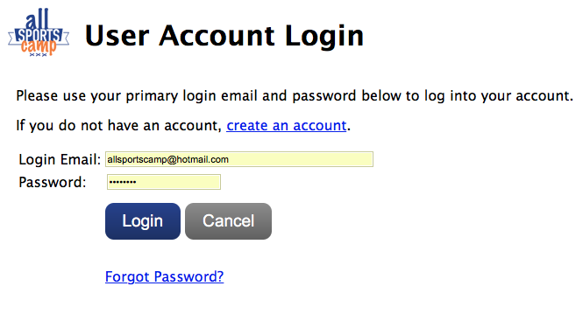

- Add your children or edit an existing child’s information.

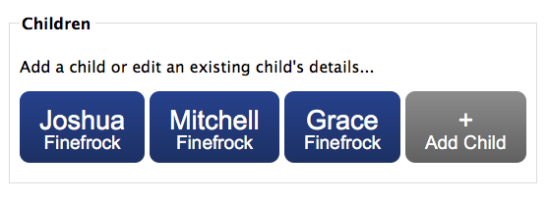

- Add your credit card.

- Click manage camp dates and enter location to access registration calendar.

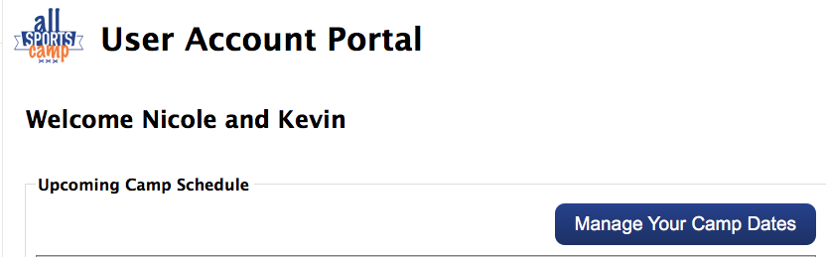

7. Select your camp days.
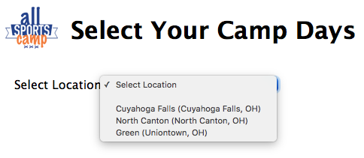
- As you enter your camp dates your invoices will appear on the right side of your screen.

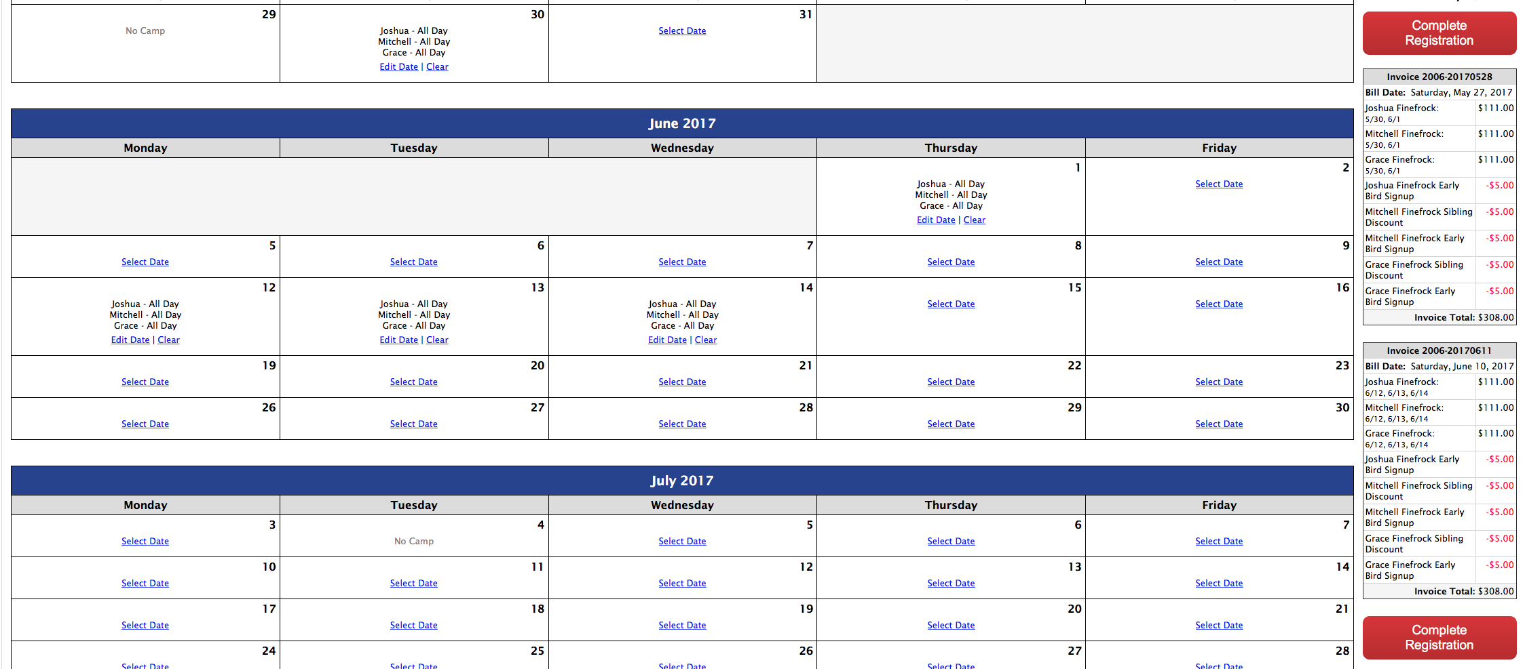

- After selecting your days click complete registration.

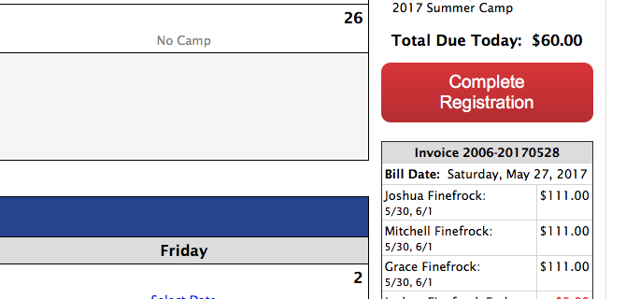

- Click process card.

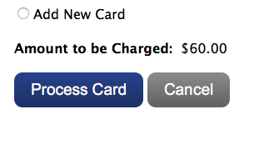

- Your will receive a confirmation message.

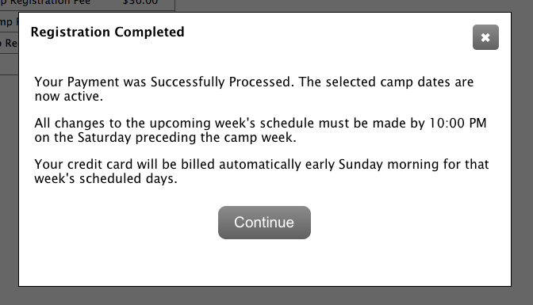

- The only payment due when registering is the registration fee. All other payments will be automatically charged to your credit card on Sunday at 8pm before camp week.

- Families can make changes to their schedule until Sunday (8pm) before camp week. Families should enter all the dates they expect their children to attend in order to guarantee a spot.

Updated 1.14.18
Updated 12.31.22

